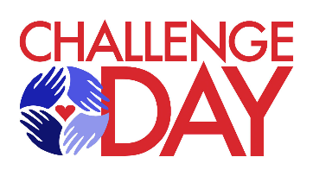
Re: Sponsorship for Challenge Day, 2026

Greetings,
For over twenty years, the MLK Committee, in partnership with local organizations like Jackson Chamber, Jackson County ISD, and Jackson College, has hosted Middle School Challenge Days for 7th-grade students in November. Jackson County ISD serves as the fiscal agent for the program.
Challenge Days are impactful, one-day workshops designed to foster self-reflection, empathy, and positive change in our schools and communities. Through engaging activities, students are empowered to create a safe and supportive school environment.
The program has resulted in increased self-esteem, reduced bullying, and improved school climate. We aim to offer this program to every 7th-grade student in Jackson County each year, with an estimated cost of $65 per student.
Dozens of community members generously volunteer to facilitate small group discussions, helping to build trust and connection with students. In addition, committee liaisons continue the work beyond the event by supporting school counselors and coordinators with follow-up activities that reinforce and sustain a positive school culture.

To sustain the program, we are seeking funding. Below are our sponsorship levels:
- Corporate Sponsor - $10,000 (154 students)
  - Organization name and/or logo placement and recognition at the MLK Jr. Diversity Breakfast, website, press releases, social media and 8 challenge day t-shirts

- Platinum Sponsor - $5,000 (77 students)
  - Organization name and/or logo placement and recognition at the MLK Jr. Breakfast, website, press releases, social media and 4 challenge day t’shirts
- School Sponsor - $2,500 ( Provides sponsorship for a 7th grade class at a school of your choice)
  - Organization name and/or logo placement and recognition at the MLK Jr. Diversity Breakfast, website, press releases, and social media.
- Silver Sponsor - $1,000 (15 students)
  - Organization name and/or logo placement and recognition at the MLK Jr. Diversity Breakfast.
- Bronze Sponsor - $500 (7 students)
  - Acknowledgement at the MLK Jr. Diversity Breakfast
- Friend of Challenge Days - $65 (1 student)
We would be grateful for your support.
Please mail Sponsor Check to: Jackson County ISD/Challenge Day, 6700 Browns Lake Road, Jackson, MI 49201.
Please visit our website to find out more information about Challenge Day and to get information on volunteering. www.jacksonmiddleschoolchallenge.org.

Sincerely,

MLK Committee Member
Jackson Middle School Challenge Days
cmcbrech@gmail.com/517.745.3598

